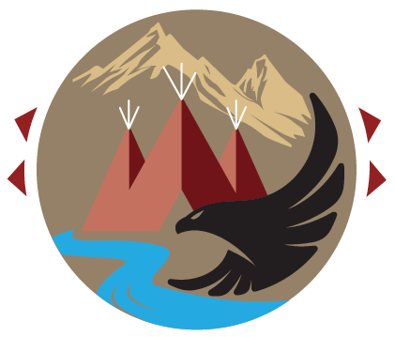
Rocky Mountain Tribal Leaders Council

2929 3rd Avenue North, Suite 300, Billings, Montana 59101
Ph: (406) 252-2550 Fax: (406) 254-6355 Web: www.rmtlc.org

Resolution #

A RESOLUTION TO SUPPORT THE DEVELOPMENT OF A TRAUMA TO RESILIENCY INITIATIVE

WHEREAS, the Rocky Mountain Tribal Leaders Council (TLC) has been created for the express purpose of providing its member Tribes with a unified voice and collective organization to address issues of concern to the Tribes and Indian people; and

WHEREAS, the Board of Directors of the TLC consists of duly elected Tribal Chairs, Presidents, and Council Members who are fully authorized to represent their respective Tribes; and

WHEREAS, as a manifestation of their solemn duty, the Tribal governments actively engage in policy formation on any matters that affect the Tribes and reservations; and

WHEREAS the TLC is dedicated to assisting and promoting the health needs and concerns of Indian people; and

WHEREAS, Mental Health is the number one priority for tribes in the Billings Area. The status of American Indians is far below the general population, the unmet health needs are significant, and an unacceptable level of health disparity exists in Montana where American Indians die 20 years earlier than the white population. These long-standing health disparities exists in large part due to historical and current intergenerational traumas imposed on our tribal populations, creating a mental health emergency; and

WHEREAS the TLC views the recent physician pedophile as another example of current trauma, resulting in another layering of new trauma on top of a long history of trauma imposed on members of the regional tribes in Montana and Wyoming; and

WHEREAS the RMTLC, serves to support needed regional health care efforts; and

NOW, THEREFORE, BE IT RESOLVED, the TLC requests funds to support a multi-year initiative to fund tribes and Urban Indian Programs, working together across Montana and Wyoming, to develop and implement a “Trauma to Resiliency” approach that will support tribal members in their ability to recognize specific behaviors and needs they may have because of past or ongoing trauma. This initiative will include measures to lessen the impacts of trauma and will be specific to recognizing how trauma impacts a person’s mental, behavioral, emotional, physical, and spiritual wellbeing. It is the desire to develop a new resiliency approach that is unique to this regions tribal cultures and will help to move this regions’ tribal members fully toward, physical, mental, social, and spiritual health.

